EVENT DESCRIPTION SHEET
(To be filled in and uploaded as deliverable in the Portal Grant Management System, at the due date foreseen in the system.
Please provide one sheet per event (one event = one workpackage = one lump sum).)
PROJECT
Participant: | ETUDES ET CHANTIERS ILE INITIATIVES LOCALES POUR L'EMPLOI
PIC number: | 942672288
Project name and acronym: | Proactive Green Communities and Storytellers for Natural Capital Safeguarding — PRO.GRE.S.S.

EVENT DESCRIPTION
Event number: | Wp4
Event name: | RISKS GENERATED BY CLIMATE CHANGE ON THE GRAND SITE OF CONCA D'ORU
Type: | T4.1 Activities with working groups on specific subjects.  T4.2 Conference oline
In situ/online: | Online
Location: | Bastia
Date(s): | 29th on September 2023
Website(s) (if any): | https://www.arciviterbo.it/progress-project/2023/10/10/first-conference-france/
Participants
Female: | 72
Male: | 66
Non-binary: | 0
From country 1 [Italy]: | 34
From country 2 [France]: | 73
From country 3 [Greese]: | 7
From country 1 [Spain]: | 24
Total number of participants: | 138 | From total number of countries: | 4
Description
Provide a short description of the event and its activities.
ECILE organised the 1st international online conference "Risques générés par le changement climatique sur le grand site de France de la Conca d’Oru”, on the 29th of september 2023 (WP4, task 4.2).
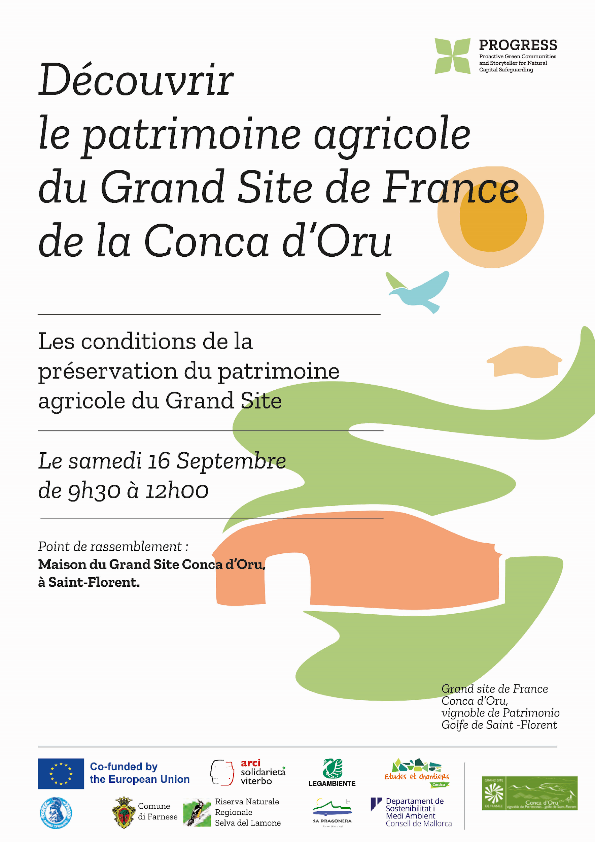
Previous to the celebration of the international conference, one activitiy was carried out with the local community on Saturday, September 16, as part of the Heritage Days in France.

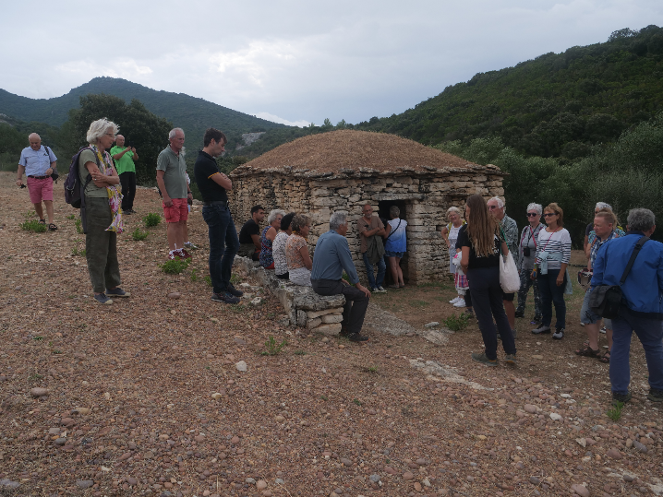

The conference was held as an online event with a duration of 60 minutes. 138 participants from the four countries involved in the project attended the Conference (Spain, France, Greece and Italy). In order to facilitate the participation of local communities from all territories involved in the project, two types of measures were carried out to overcome language and ICT barriers:
- On the one hand, simultaneous interpretation was provided from French into Spanish, Greek and Italian. *
- On the other hand, a meeting room was made available in the municipalities of Bastia, Porto Vecchio, and in thus anyone who needed could follow
The conference from the 2 meeting rooms gathered 43 people that took advantage of these facilities.
The conference focused on the risks generated by climate change.
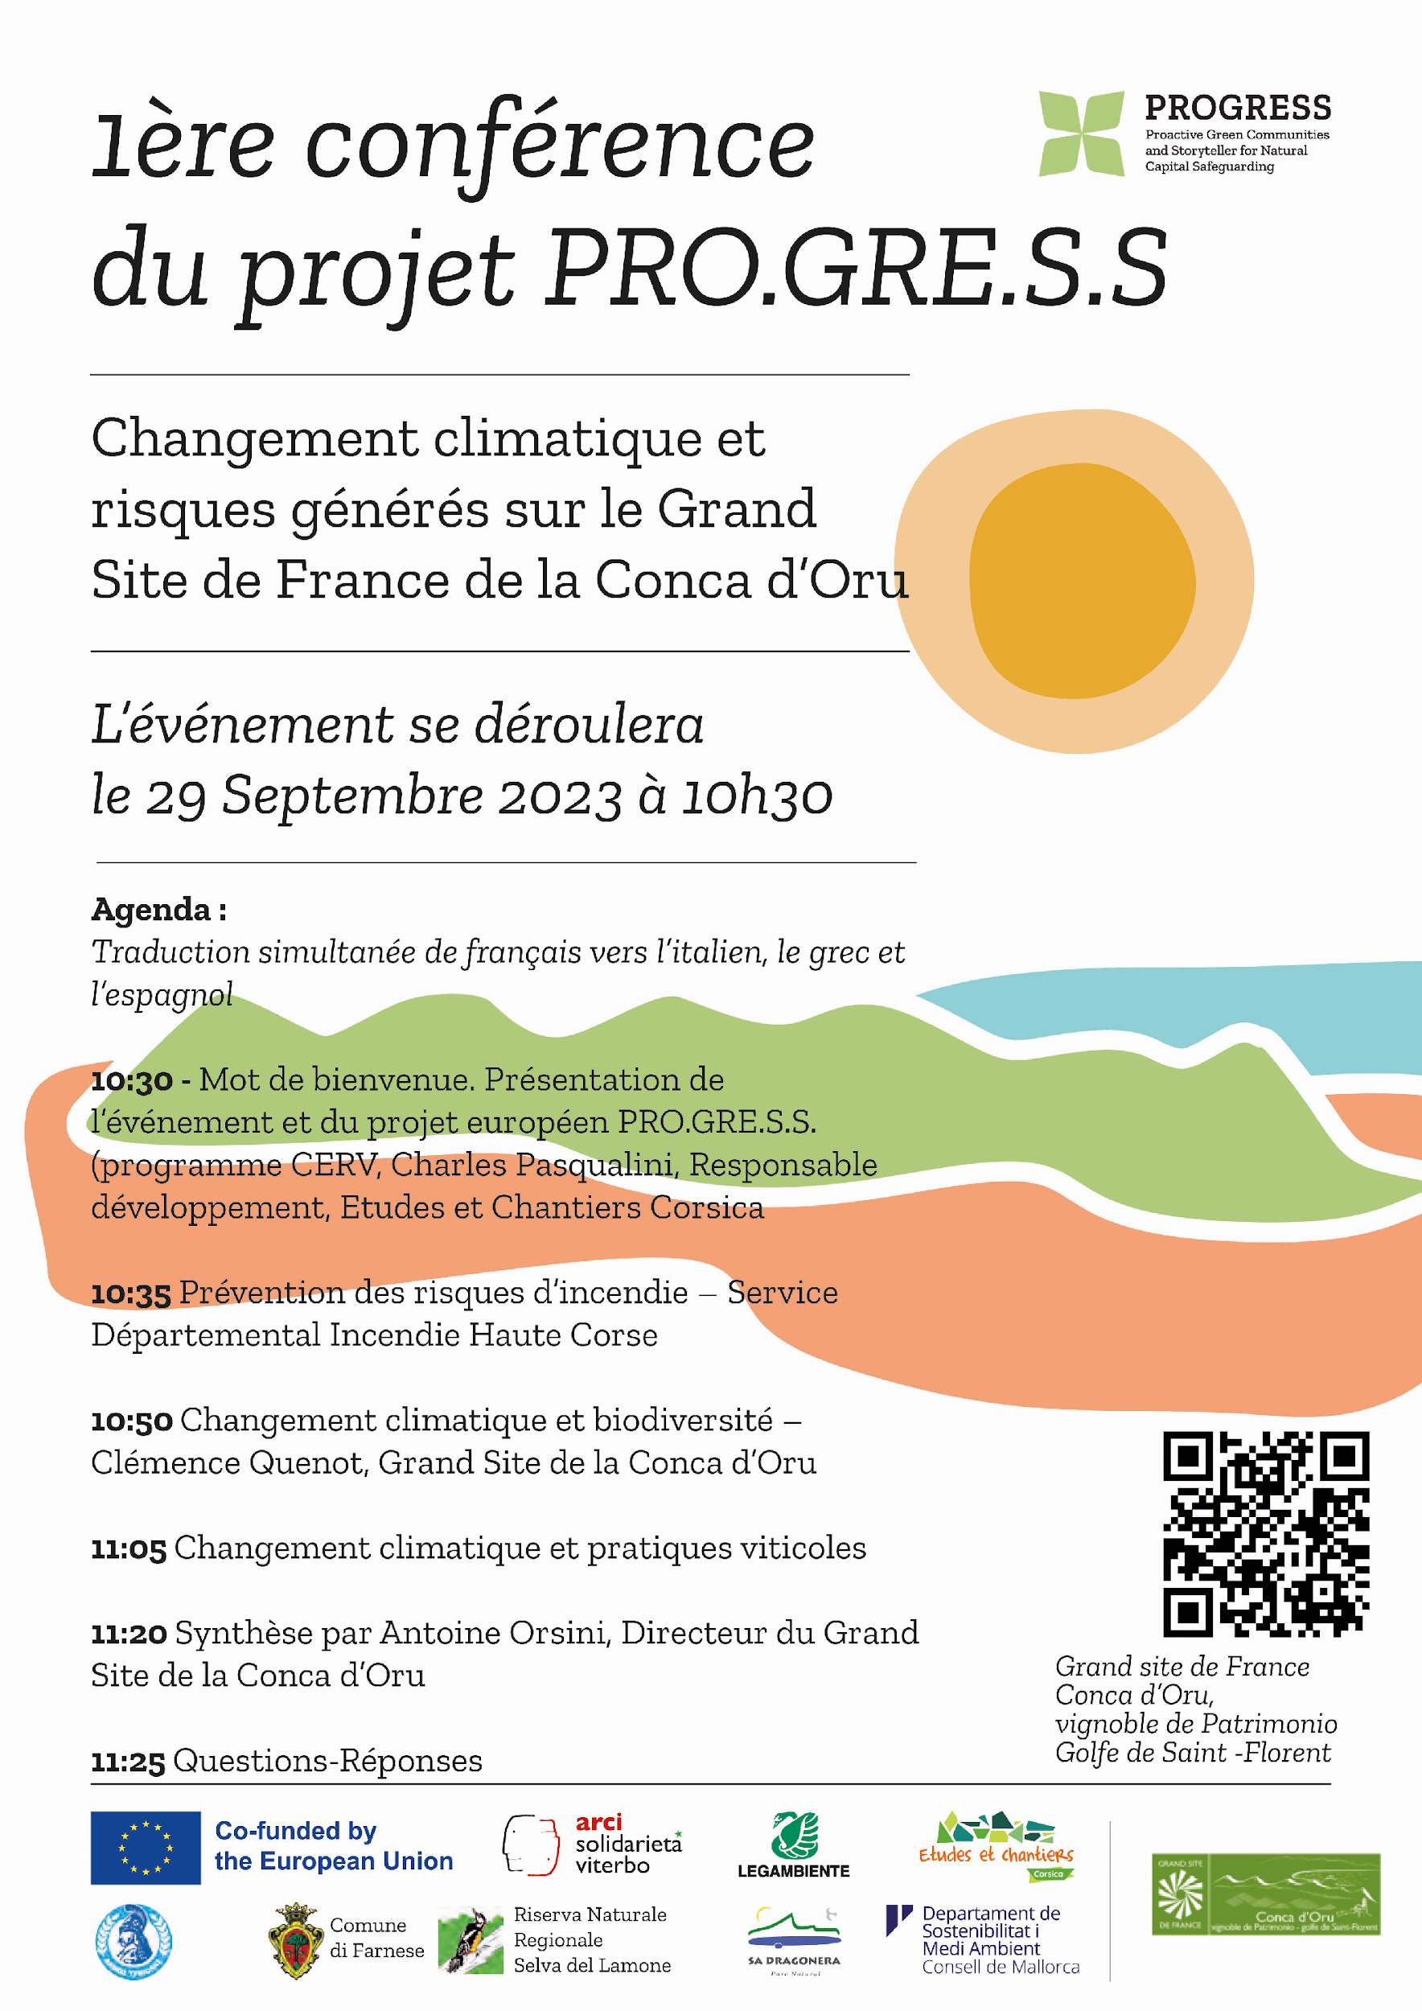
The presentations were as follows;
- "Climate Change and Vine-Growing Practices in Grand Site Conca D’Oru; Antoine Orsini, Grand Site Director
- Climate Change and Wildfire Prevention; Haute Corse Fire Department, Lieutenant Colonel Meschini, Lieutenant Colonel Rigot, and National Forestry Office, Gilles Planelles
- Climate Change and Biodiversity; Clémence Quenot, Grand Site Development and Engineering CO
- Summary of Risks on the Grand Site; Antoine Orsini"

HISTORY OF CHANGES
VERSION | PUBLICATION DATE | CHANGE
1.0 | 01.04.2022 | Initial version (new MFF).

